PHYS.1410L (Physics I Lab)

IMPULSE AND MOMENTUM IN COLLISIONS

INTRODUCTION

Collisions can be used to study the details of forces. Typical analysis of collisions involves using the principle of conservation of linear momentum as this is one of the most useful conservation laws in physics. Alternatively, the details of the force during a collision can be measured directly and compared to the change in the linear momentum, which is the approach taken in this experiment. In addition, the conservation of mechanical energy will be investigated.

THEORETICAL BACKGROUND

The standard formulation of Newton’s second law can easily be transformed into the Impulse-Momentum Theorem by first rewriting it in terms of linear momentum.

$$\vec{F}=m\vec{a}=m\frac{d\vec{v}}{dt}=\frac{d(m\vec{v})}{dt}= \frac{d\vec{p}}{dt}$$

In this form, Newton’s second law expresses the fact that the net force on an object equals the rate of change of its linear momentum $(\vec{p})$. Simple mathematical manipulation of this expression leads to the “Impulse-Momentum Theorem”, where$\vec{J}$ equals the impulse.

$$\vec{J}≡\int_{t_{i}}^{t_{f}}{\vec{F}}dt=\int_{t_{i}}^{t_{f}}{d\vec{p}} = ∆\vec{p}$$

[Impulse-Momentum Theorem]

Hence, the impulse equals the area under the force versus time curve and is also equal to the change in linear momentum, i.e. the net effect of a force being applied for a given time interval is to change the linear momentum of the object acted on by the force.

If the specific time dependence of the force is not known explicitly, the relationship can be approximated as:

$$\vec{J}= {\vec{F}}_{ave}∆t= ∆\vec{p}$$

Note: In this experiment the direct measurement of the forces involved during the collision between a spring and a cart will result in the time-dependence of the force and will demonstrate the Impulse-Momentum Theorem.

There are two types of mechanical energies involved in this experiment –the kinetic energy of a moving cart and the elastic potential energy of a compressed spring.

The kinetic energy of an object is defined to be:

$$K= \frac{1}{2}mv^{2}$$

The elastic potential energy stored in a spring that is compressed (or stretched) is given by:

$$U_{sp}= \frac{1}{2}k{(Δx)}^{2}$$

Note: The conservation of mechanical energy will be studied in this experiment by comparing the kinetic energy of the cart before and after the collision with the spring. A moving cart will collide with and compress a spring, and then rebound from the spring. The kinetic energy of the cart will first be completely transformed to elastic potential energy as the spring momentarily stops the cart. Then the elastic potential energy of the spring will be transformed back into kinetic energy of the cart.

EXPERIMENTAL APPARATUS

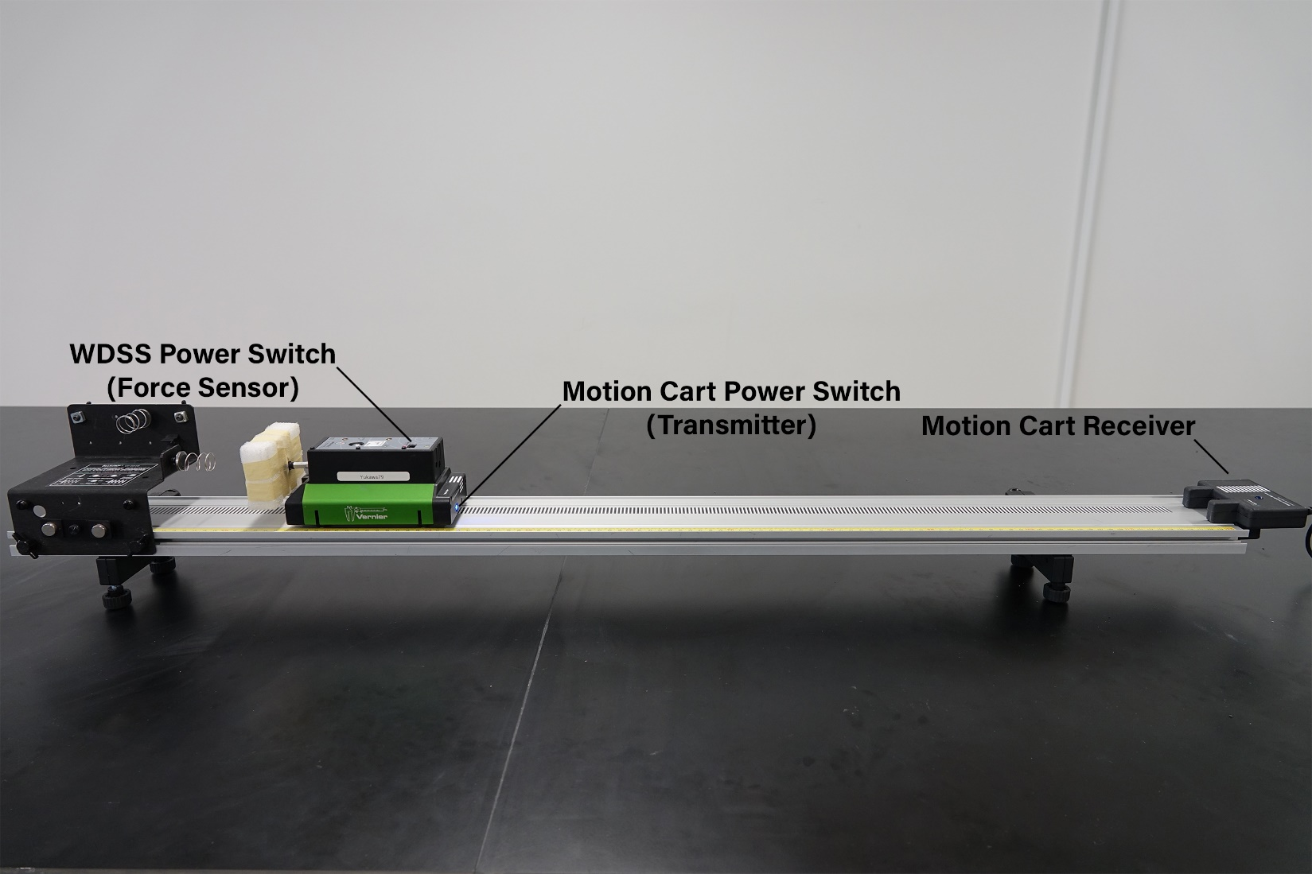

As shown in the picture above, the apparatus consists of a horizontal track, a motion cart (with a force sensor), a receiver (position detector), and a spring held in a bracket.

MEASUREMENTS
Set up an EXCEL spreadsheet to record the mass of the cart, the velocities of the cart before and after the collision, and the impulse in addition to the maximum force during the collision. The spreadsheet should also include columns for calculated values of the initial and final values for momenta and kinetic energy along with comparisons.

Preliminary Procedures
Use a balance to determine the mass of the cart with the force sensor attached.
Turn on the motion cart power switch and the WDSS power switch (force sensor).
Open the program “Impulse Momentum v2”.
When the program indicates that the force sensor is not connected, press the ‘Scan for WDSS’ button.
Choose the force sensor name that matches the name on your cart and select ‘OK’ connect.

Data collection using the light spring

Screw the light spring into the bracket.
Press the zero button (next to the collect button on the top menu bar).

Take three runs using the following procedures:
Hold the end of the track during data runs so that it doesn’t move when the cart strikes the spring.
Hit the ‘collect’ button and then push the cart towards the spring, letting it hit the spring and rebound.
(Be sure to stop the cart before it hits the motion cart receiver.)
Note: Data will be recorded for a time interval of 5 seconds after you hit the collect button.

Preliminary Data Analysis
Two graphs will be displayed – velocity versus time and force versus time.
Choose the velocity graph and zoom in on the region containing the collision.
Select a region that includes just the collision time interval and press the ‘statistics’ button in the top menu, which will then display the maximum (initial) and minimum (final) velocities.
Choose the force graph and again zoom in on the region containing the collision.
Print out graphs for velocity versus time and force versus time for one of your data runs.
From the ‘analyze’ menu, select ‘integral’ to obtain the impulse.
Check to see that the data collected gives reasonable results.

Data collection using an air bag
Remove the spring.
Use a zip-lock bag as an air bag. Inflate it using a straw, leaving it open a few cm. Tape the bag to the bracket.
Your goal is to have the cart’s final velocity be zero, without striking the bracket. To accomplish this you will need to adjust the opening of the bag and the speed of the cart. Record the maximum force for two runs, one with a small initial velocity and one with a larger initial velocity.
Print out graphs for velocity versus time and force versus time for one of your data runs.

Data collection using no air bag
Now remove the air bag. Record the maximum force for two runs that approximately match the initial velocities used for the air bag runs.
Print out graphs for velocity versus time and force versus time for one of your data runs.

Procedures after completing data collection

Turn off the motion cart power switch and the WDSS power switch (force sensor).

ANALYSIS

Analyze your results from the values in your EXCEL spreadsheet. This should include consideration of the impulse-momentum theorem and the law of conservation of mechanical energy.

QUESTIONS
- A vehicle of mass 2.7 x 10³ kg impacts an immovable test barrier and comes to a complete stop.

- If the sensors on the barrier indicate an impulse of 6.3 x 10⁴ N-s for the crash, determine the initial velocity of the vehicle (in m/s and mi/h).

- If the crash lasts for 3.5 x 10⁻³ s, determine the average force (in N and lb) on the vehicle.

- A ball is projected at an immovable wall with a speed v_{i} and bounces back the wall in such a manner that it only has 1/3 of its original linear momentum.

- Determine what fraction of the kinetic energy is lost in the collision.

- What happened to the kinetic energy that was lost?

